Prepare specflow project

Right clickon the project and goto>manageNuget Packages

Browse for

Extentreports

Download the plugin

Again rightclick on project add class

Give the name as TestSteps.cs

using AventStack.ExtentReports;

using AventStack.ExtentReports.Gherkin.Model;

using AventStack.ExtentReports.Reporter;

using System;

using System.Collections.Generic;

using System.Linq;

using System.Text;

using System.Threading.Tasks;

namespace SpecFlowTestReportUsingExtentReport

{

[Binding]

class TestSteps

{

private static ExtentTest featureName;

private static ExtentTest scenario;

private static ExtentReports extent;

private static string ReportPath;

[BeforeTestRun]

public static void BeforeTestRun() {

string path1 = AppDomain.CurrentDomain.BaseDirectory.Replace("\\bin\\Debug", "");

string path = path1 + "\\Reports\\index.html";

ExtentHtmlReporter htmlReporter = new ExtentHtmlReporter(path);

htmlReporter.Config.Theme = AventStack.ExtentReports.Reporter.Configuration.Theme.Standard;

extent = new ExtentReports();

extent.AttachReporter(htmlReporter);

}

[BeforeFeature]

public static void BeforeFeature()

{

featureName = extent.CreateTest<Feature>(FeatureContext.Current.FeatureInfo.Title);

Console.WriteLine("Before Feature");

}

[BeforeScenario]

public static void BeforeScenario()

{

scenario = extent.CreateTest<Feature>(ScenarioContext.Current.ScenarioInfo.Title);

Console.WriteLine("Before Scenario");

}

[AfterStep]

public void InsertReportingSteps()

{

var stepType = ScenarioStepContext.Current.StepInfo.StepDefinitionType.ToString();

if (ScenarioContext.Current.TestError == null)

{

if (stepType == "Given")

scenario.CreateNode<Given>(ScenarioStepContext.Current.StepInfo.Text);

else if (stepType == "When")

scenario.CreateNode<Given>(ScenarioStepContext.Current.StepInfo.Text);

else if (stepType == "Then")

scenario.CreateNode<Given>(ScenarioStepContext.Current.StepInfo.Text);

else if (stepType == "And")

scenario.CreateNode<Given>(ScenarioStepContext.Current.StepInfo.Text);

}

else if (ScenarioContext.Current.TestError != null) {

if (stepType == "Given")

scenario.CreateNode<Given>(ScenarioStepContext.Current.StepInfo.Text).Fail(ScenarioContext.Current.TestError.Message);

else if (stepType == "When")

scenario.CreateNode<Given>(ScenarioStepContext.Current.StepInfo.Text).Fail(ScenarioContext.Current.TestError.Message);

else if (stepType == "Then")

scenario.CreateNode<Given>(ScenarioStepContext.Current.StepInfo.Text).Fail(ScenarioContext.Current.TestError.Message);

else if (stepType == "And")

scenario.CreateNode<Given>(ScenarioStepContext.Current.StepInfo.Text).Fail(ScenarioContext.Current.TestError.Message);

}

}

[AfterScenario]

public void AfterScenario()

{

Console.WriteLine("After Scenario");

}

[AfterTestRun]

public static void AfterTestRun()

{

extent.Flush();

}

[Given(@"i have entered into calculator")]

public void GivenIHaveEnteredIntoCalculator()

{

}

[Given(@"first number is one")]

public void GivenFirstNumberIsOne()

{

}

[When(@"second number is five")]

public void WhenSecondNumberIsFive()

{

}

[Then(@"total is six")]

public void ThenTotalIsSix()

{

}

}

}

Build the project

And run the test cases

You will see one net6.0 folder is prepared automatically under your project as shown below

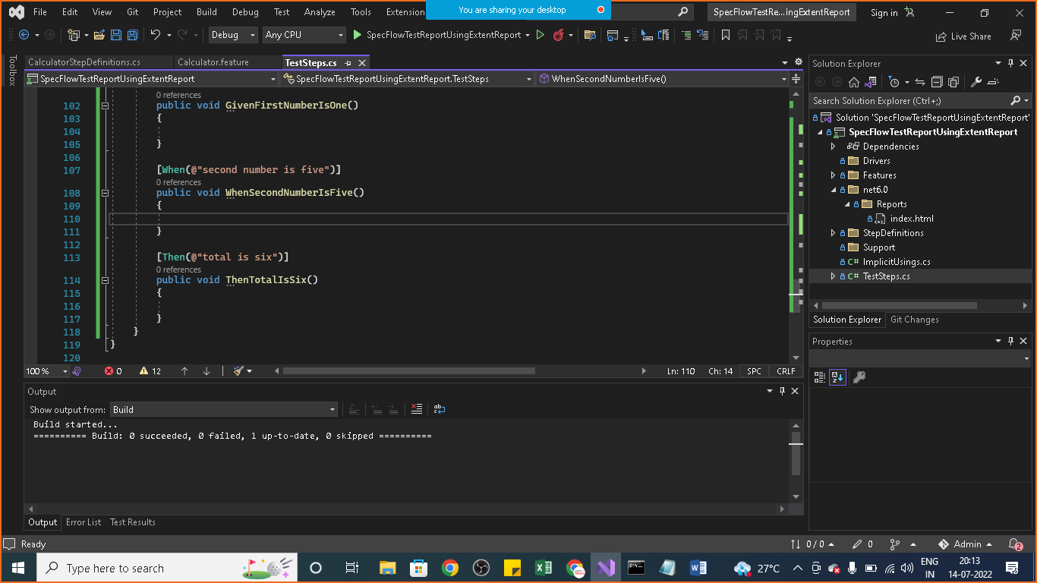

Goto> net 6.0>Reports>index.html file

Open in system explorer and open index.html file and see the output

